 | 12.1.14 Editors - Geometry Nodes Editor - Header - Add Menu - Point
Table of content
Detailed table of content 1
Add menu - Point 4
Distribute Points on Faces 4
Instance on Points 5
Mesh to Points 6
Legacy Point Nodes 6
Align Rotation to Vector 7
Point Distribute 7
Point Instance 8
Point Rotate 9
Point Scale 10
Point Separate 11
Point Translate 11

Detailed table of content
Detailed table of content
Detailed table of content 1
Add menu - Point 4
Distribute Points on Faces 4
Inputs Random mode 4
Geometry 4
Density 4
Seed 4
Inputs Poisson Disk mode 4
Geometry 4
Distance Min 4
Distance Max 4
Density Factor 4
Seed 4
Selection 5
Properties 5
Distribution method 5
Random 5
Poisson Disk 5
Output 5
Points 5
Normal 5
Rotation 5
Stable ID 5
Instance on Points 5
Inputs 5
Points 5
Instance 5
Pick Instance 5
Rotation 5
Scale 6
Output 6
Instances 6
Mesh to Points 6
Inputs 6
Mesh 6
Position 6
Radius 6
Selection 6
Properties 6
Mode 6
Output 6
Points 6
Legacy Point Nodes 6
Align Rotation to Vector 7
Inputs 7
Geometry 7
Factor 7
Vector 7
Properties 7
Axis 7
Factor 7
Vector 7
Outputs 7
Geometry 7
Point Distribute 7
Inputs 7
Geometry 7
Distance Min 8
Density Max 8
Density Attribute 8
Seed 8
Properties 8
Distribution Method 8
Random 8
Poisson Disk 8
Seed 8
Output 8
Geometry 8
Point Instance 8
Inputs 9
Geometry 9
Object / Collection 9
Properties 9
Instance Type 9
Outputs 9
Geometry 9
Point Rotate 9
Inputs 9
Geometry 9
Rotation 9
Properties 9
Rotate Type 9
Axis Angle 9
Euler 9
Rotate Space 9
Object 9
Point 10
Input Type Rotation 10
Outputs 10
Geometry 10
Point Scale 10
Inputs 10
Geometry 10
Translation 10
Properties 10
Type 10
Attribute 10
Vector 10
Output 10
Geometry 10
Point Separate 11
Inputs 11
Mask 11
Outputs 11
Geometry 1 11
Geometry 2 11
Point Translate 11
Inputs 11
Geometry 11
Translation 11
Properties 11
Type 11
Attribute 11
Vector 12
Output 12
Geometry 12

Add menu - Point
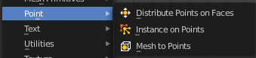

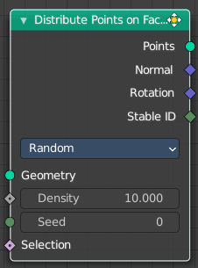
Distribute Points on Faces
Distributes points randomly on the faces of a mesh geometry.

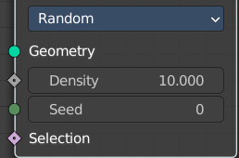
Inputs Random mode

Geometry
Standard geometry input.

Density
Density of the points.

Seed
The random seed for the point distribution.

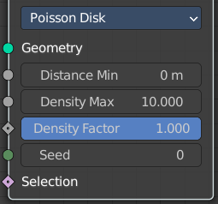
Inputs Poisson Disk mode

Geometry
Standard geometry input.

Distance Min
The minimum distance that two points can have.

Distance Max
The naximum distance that two points can have.

Density Factor
Density of the points.

Seed
The random seed for the point distribution.

Selection
Input selection.

Properties

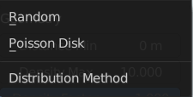
Distribution method

Random
Distributes the points randomly. This allows overlappings.

Poisson Disk
Distributes the points randomly, but prevents overlappings by defining a minimum and maximum distance.

Output

Points
Points output.

Normal
Normal output.

Rotation
Rotation output.

Stable ID
Stable ID output.

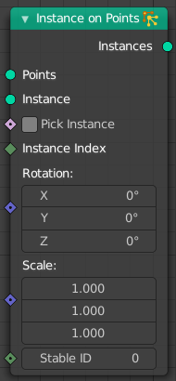
Instance on Points
Instances geometry on points.

Inputs

Points
Standard points input.

Instance
Instance input.

Pick Instance
Not documented yet.

Rotation
The initial rotation.

Scale
The initial scale.

Output

Instances
Instances output.

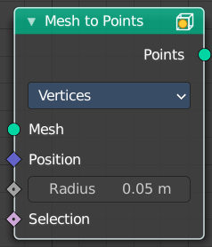
Mesh to Points
Converts the vertices of a mesh to points.

Inputs

Mesh
Standard mesh input.

Position
Position input.

Radius
Not documented yet.

Selection
Selection input.

Properties

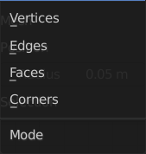
Mode
What geometry to convert.

Output

Points
Standard points output.

Legacy Point Nodes

These nodes existed in a former Bforartists version, but are now deprecated. They do not show in the regular menu or UI anymore. And you cannot insert them in a newer Bforartists version. But old projects that uses this nodes still loads with these nodes showing and enabled.

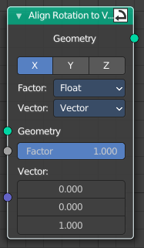
Align Rotation to Vector
The Align Rotation to Vector node rotates points into a given direction. It uses the Rotation attribute for that.

Inputs

Geometry
Standard geometry input.

Factor
Determines how much the points are rotated towards the vector. Zero effectively disables the node and one means that the points are aligned with the vector perfectly.

Vector
The direction vector that points should be rotated to. The vector is in the local space of the object that is being modified. When it is all zeros for a point, it is not rotated at all.

Properties

Axis
Local axis of the object that is to be rotated towards the vector input.

Factor
Type of the Factor input socket.

Vector
Type of the Vector input socket.

Outputs

Geometry
Standard geometry output.

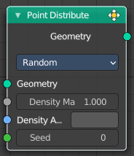
Point Distribute
The Point Distribute node distributes points on the surface of the input geometry object.

Inputs

Geometry
Standard geometry input. Note that only meshes are supported.

Distance Min
The minimal distance points can have to each other. Note that this option is only available on distribution methods that supports it.

Density Max
The point density for the point distribution. In other words, how many points there will be within one square meter. Note that this will be capped on distributions with the Distance Min option. If the density is greater than what the minimal distance allows, no new points will be added after this threshold has been passed.

Density Attribute
Which attribute to use for influencing the point density. The input values are mapped between zero and the Density.

Seed
Random seed input.

Properties
This properties most probably just shows under some circumstances, which we haven't managed to reproduce yet. The Blender manual does not give any hint here.

Distribution Method

Random
Distribute points randomly on the surface.

Poisson Disk
Project points on the surface evenly with a Poisson disk distribution.

Seed
The random seed to use when generating points.

Output

Geometry
Generated points.

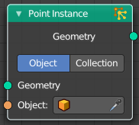
Point Instance
The Point Instance node instances an element to each of the points present in the input geometry. It works for both point cloud and mesh vertices.
Note that this node only works if the modifier belongs to a point cloud object.

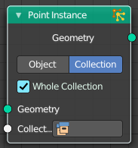
Inputs

Geometry
Standard geometry input.

Object / Collection
The object or collection to instantiate.

Properties

Instance Type
Instance an object or a collection. The input type changes dependant of the choice here.

Outputs

Geometry
Standard geometry output.

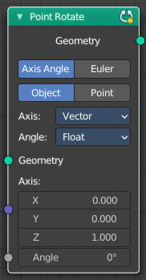
Point Rotate
Rotates points.

Inputs

Geometry
Use the rotation of an existing geometry.

Rotation
The input rotation. Baset at a vector, or based at an attribute.

Properties

Rotate Type

Axis Angle
Rotate around an axis by an angle.

Euler
Rotate around the x, y and z axis.

Rotate Space

Object
Rotate points in the local space of the object.

Point
Rotate every point in its local space.

Input Type Rotation
If the rotation is based at an attribute or at an vector.

Outputs

Geometry
Standard geometry output.

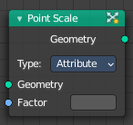
Point Scale
Changes the scale attribute of every point in the geometry by the specified amount. Either from the attribute input or a vector input. Note that the Attribute Vector Math Node comes also wwith the Multiply operation and the scale attribute functionality.
The scale attribute is used by the Point Instance Node to determine the size of every instanced object or collection.

Inputs

Geometry
Standard geometry input.

Translation
The attribute or vector input.

Properties

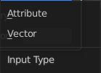
Type

Attribute
Use the values from the attribute to move each point by a different amount.

Vector
Use a single vector to translate every single point. Equivalent to the Transform Node.

Output

Geometry
Standard geometry output.

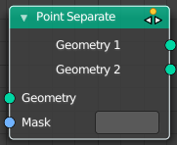
Point Separate
Produces two output geometries. The point cloud component of the input geometry is split between the two outputs, based on the threshold and the input attribute
Tip! To get a more precise result you can combine the node with the Attribute Compare node.

Inputs

Mask
The name of the attribute used to calculate which geometry output each point will belong to. Any value of “true” will move to the second output, and any value of “false” will move the point to the first output.
If the attribute has any data type besides boolean, the value will be implicitly converted, so a value of exactly zero is false, and any other value is true.

Outputs

Geometry 1
Points with a mask attribute value of “true” will be moved to the first input.

Geometry 2
Points with a mask attribute value of “false” will be moved to the first input.

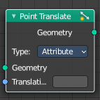
Point Translate
Moves every point of the geometry by the specified amount. Either from the attribute input or a vector input. Note that the Attribute Vector Math Node comres also with the Addition operation and the position attribute.

Inputs

Geometry
Standard geometry input.

Translation
The attribute or vector input.

Properties

Type

Attribute
Use the values from the attribute to move each point by a different amount.

Vector
Use a single vector to translate every single point. Equivalent to the Transform Node.

Output

Geometry
Standard geometry output.

